VOLUNTARY VS INVOLUNTARY SAVING MECHANISM
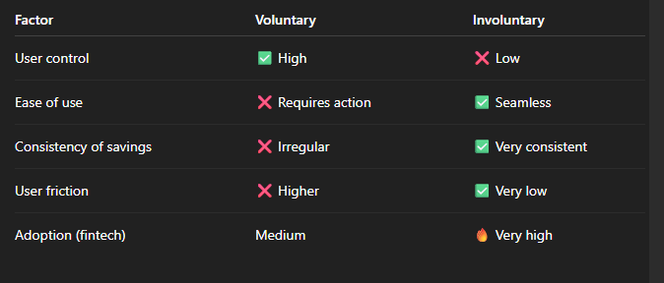

Postman
Run backend:
npm run dev

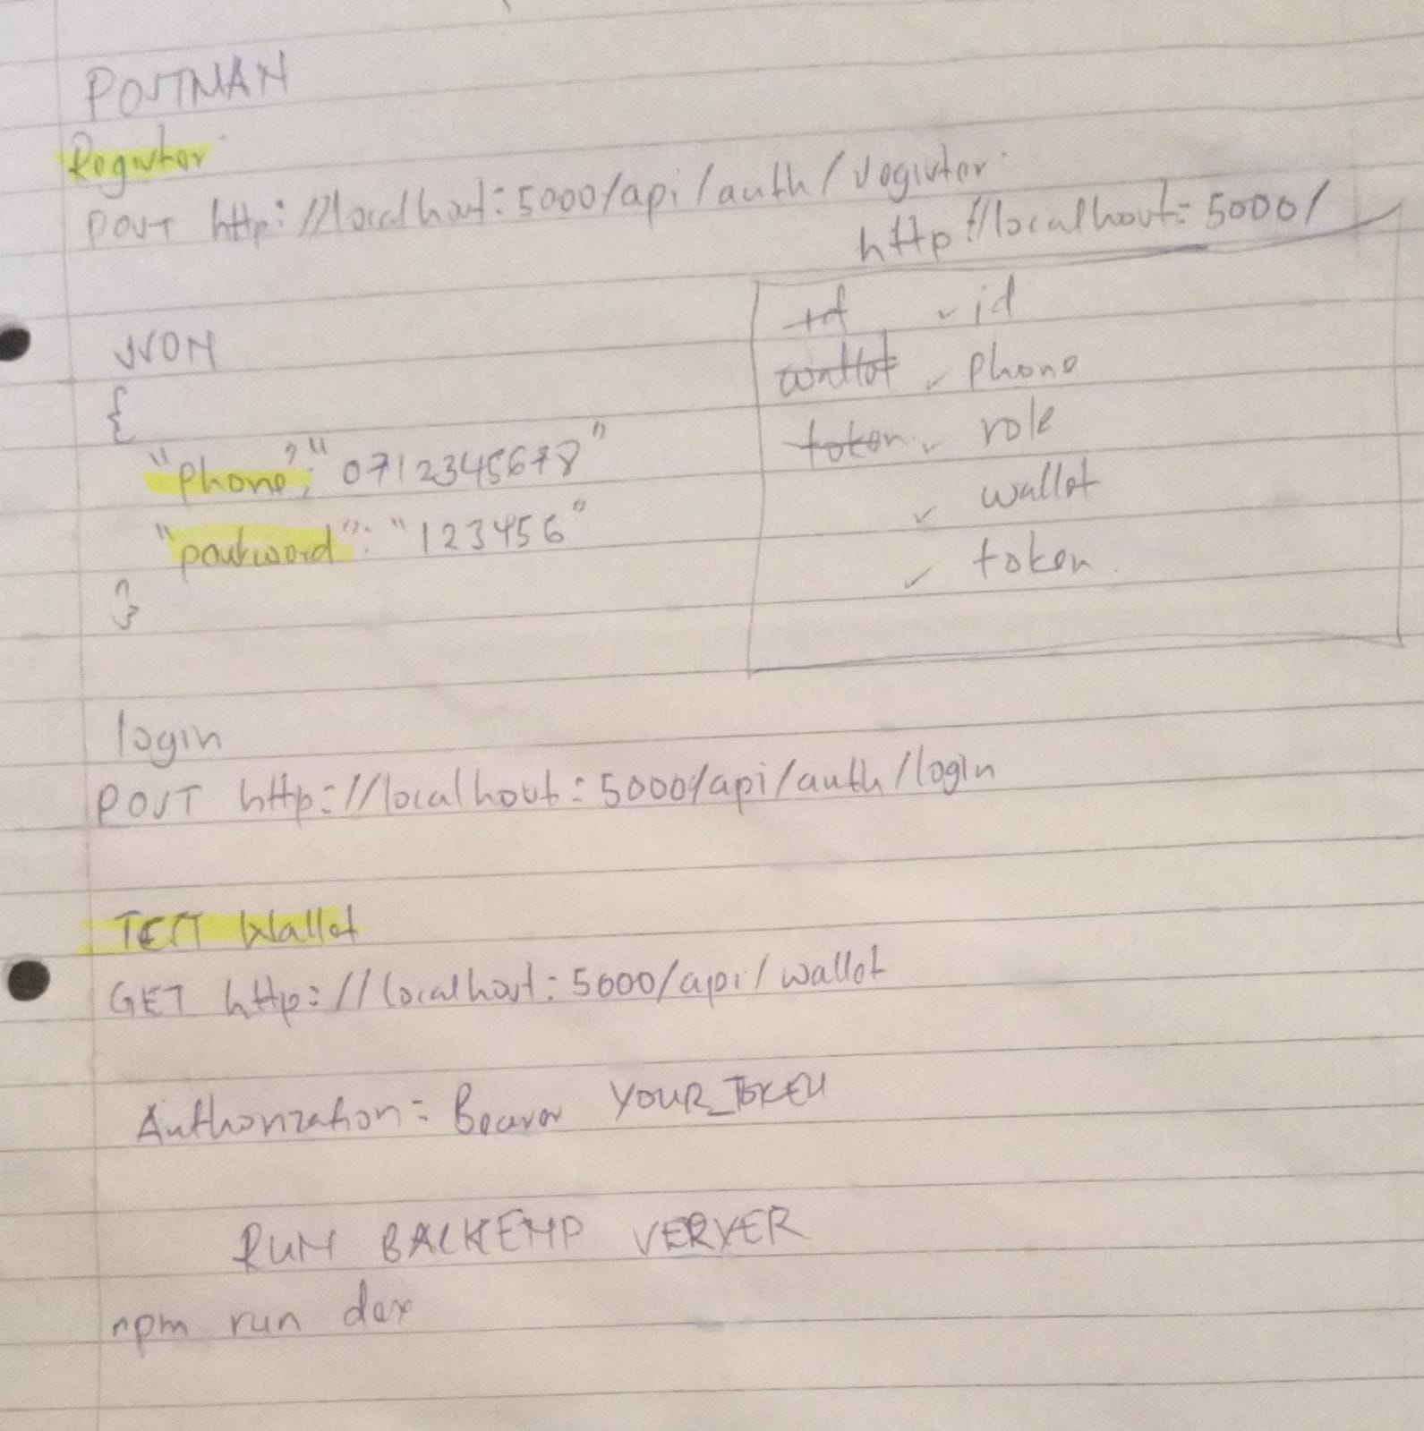

POSTMAN: SIMULATING
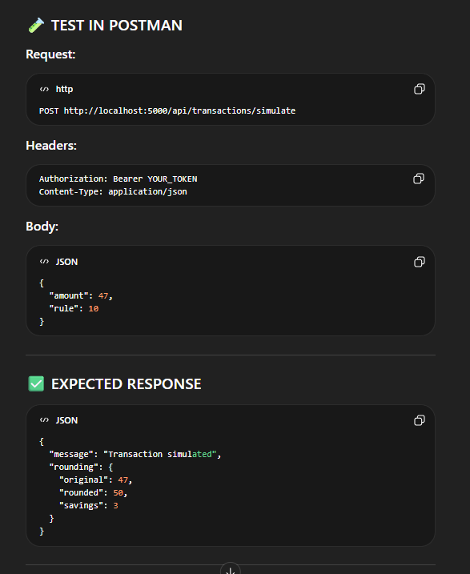

POSTMAN: Creating a goal
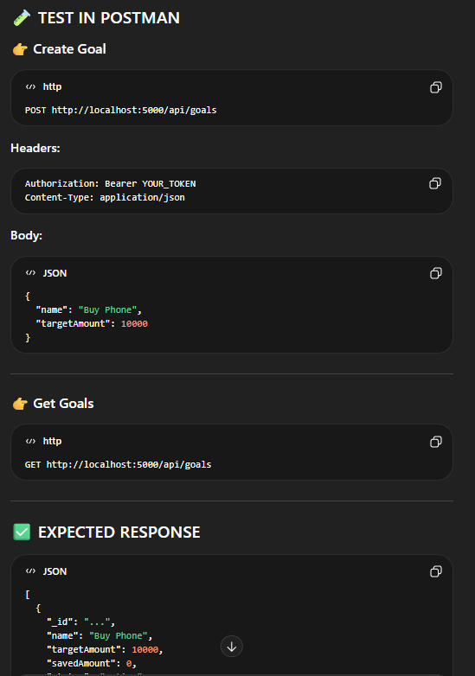

POSTMAN: Analytics
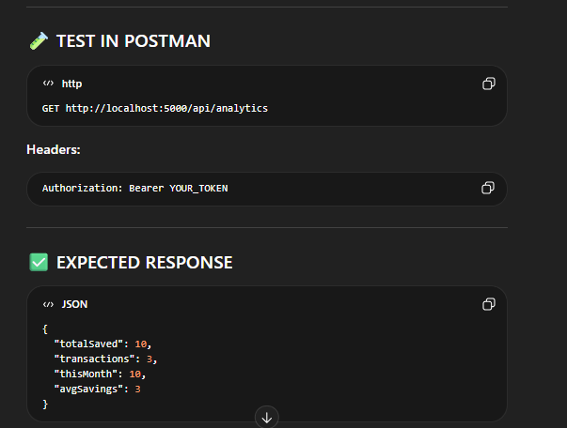
POSTMAN: Test-flow example
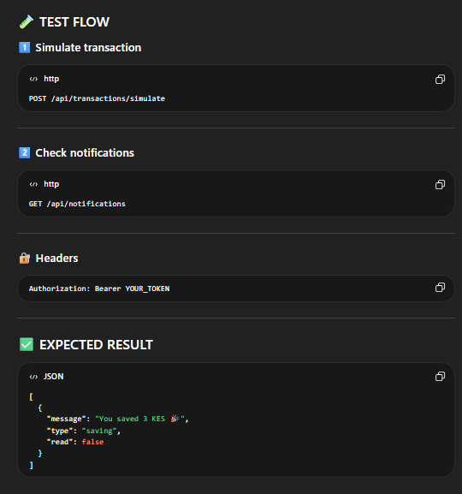

Running Frontend
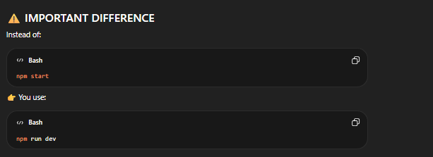
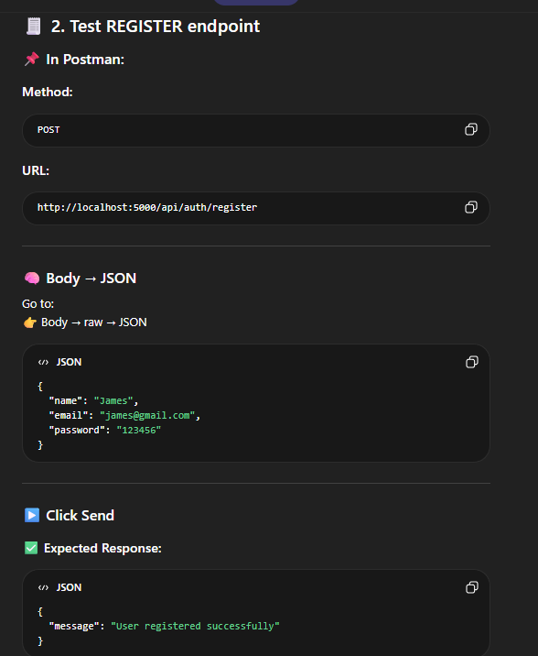
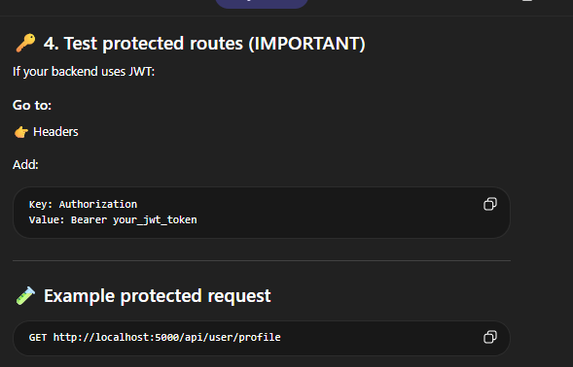
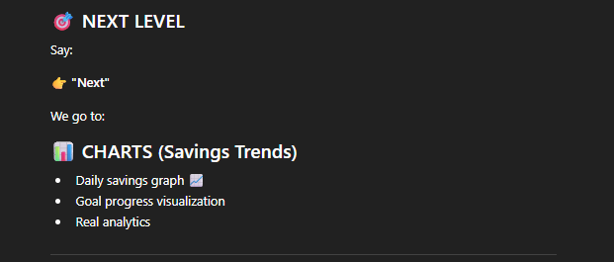

README
🌱 AirSave
AirSave is a full-stack web application designed to help users track their savings, set financial goals, and monitor progress over time through a clean and interactive dashboard.

🚀 Features
- 🔐 User Authentication (JWT-based)
- 💰 Savings Goals Management
- 📊 Dashboard with progress tracking
- 🔄 RESTful API integration
- 🧩 Scalable full-stack architecture

🛠️ Tech Stack
Frontend
- React (Vite)
- Axios
- Bootstrap / CSS
Backend
- Node.js
- Express.js
- MongoDB (Mongoose)
- JWT Authentication

⚙️ Local Development Setup

Backend
cd backend
npm install
npm run dev
Create .env:
PORT=5000
MONGO_URI=your_mongodb_connection_string
JWT_SECRET=your_secret_key

Frontend
cd frontend
npm install
npm run dev

🌍 Deployment (Render)

🔧 Backend Deployment (Render)
- Go to https://render.com
- Click New → Web Service
- Connect your GitHub repo
- Configure:
  - Root Directory: backend
  - Build Command:
  - npm install
  - Start Command:
  - node server.js
- Add Environment Variables:
  - MONGO_URI
  - JWT_SECRET
  - PORT=10000
- Click Deploy
👉 After deployment, you’ll get:
https://your-backend.onrender.com

💻 Frontend Deployment (Render)
- Click New → Static Site
- Configure:
  - Root Directory: frontend
  - Build Command:
  - npm install && npm run build
  - Publish Directory:
  - dist
- Add Environment Variable:
VITE_API_URL=https://your-backend.onrender.com/api
- Deploy
👉 Your frontend will be live on:
https://your-frontend.onrender.com

🔗 API Documentation

🔐 Auth Routes

Register User
POST /api/auth/register
Body:
{
"name": "John Doe",
"email": "john@example.com",
"password": "123456"
}

Login User
POST /api/auth/login
Body:
{
"email": "john@example.com",
"password": "123456"
}
Response:
{
"token": "JWT_TOKEN"
}

🎯 Goals Routes

Create Goal
POST /api/goals
Headers:
Authorization: Bearer <token>
Body:
{
"name": "Buy Laptop",
"targetAmount": 1000
}

Get All Goals
GET /api/goals

Update Goal Progress
PUT /api/goals/:id
Body:
{
"currentAmount": 200
}

🧪 Testing
Use Postman or Thunder Client:
- /api/auth/register
- /api/auth/login
- /api/goals

📌 Notes
- Ensure MongoDB Atlas is used in production
- Backend must be deployed before frontend
- Use environment variables for all secrets

👨‍💻 Author
James Otipa
Software Engineer

📄 License
This project is for educational and development purposes.
